import java.util.Scanner;

class Read{

String name;

String country;

String skill;

}

class Main_{

public static void main(String[] args)

{

Scanner sc=new Scanner(System.in);

Read read=new Read();

System.out.println(" Enter the player name");

read.name=sc.nextLine();

System.out.println(" Enter the country name ");

read.country=sc.nextLine();

System.out.println(" Enter the skill name");

read.skill=sc.nextLine();

System.out.println("player Details ");

System.out.println("player name:"+read.name);

System.out.println("country name:"+read.country);

System.out.println("skill name:"+read.skill);

}

}

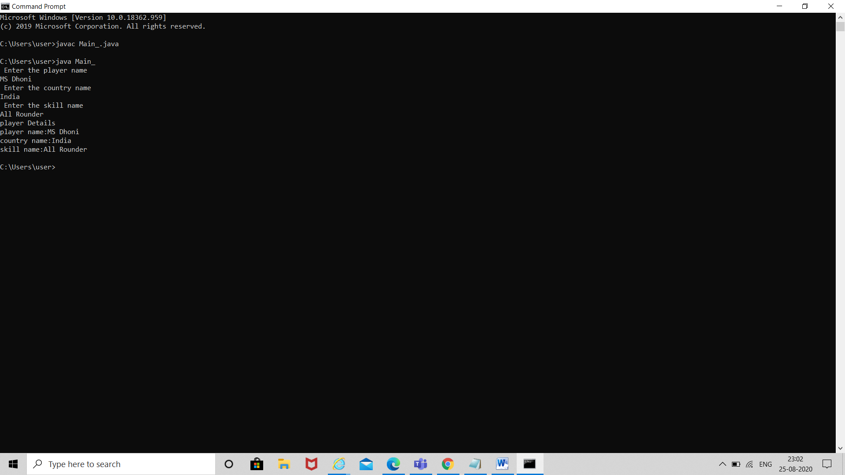vv